How to search for Call Number ranges in Alma
Simple Search:
- At the search bar in ALMA select “Physical items” on the drop down menu
- In the white drop down menu select “LC Call Number”
- In the search window input the call number range you are looking for, i.e. PN6727

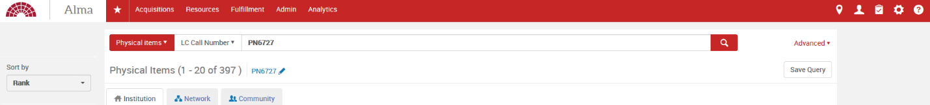

- If your search has produced a lot of results and you want to be able to sort the call numbers in order, click the Export List icon that is in the upper right just below (Save Query) and choose Excel.

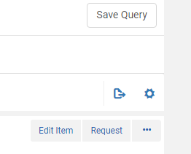

- Open the Excel file and under Column U will be a list of call numbers in that range.
- Edit, manipulate, and sort the Excel sheet to your preference.

Advanced Search:

- On the right hand side of the search bar, click “Advanced” to bring up an Advanced Search.
- Select “Physical items” on the drop down menu
- Select “Permanent call number type” in the first white drop down menu
- Select “Equals” in the second (middle) box
- Select “Library of Congress Classification” in the third box and hit the “+” symbol next to it to add another search line
- Select “AND” at the start of the second search line
- In the first white drop down menu select “Permanent call number”
- Select “Contains Keywords” in the second (middle) box
- In the third search window input the call number range you are looking for, i.e. PN6727

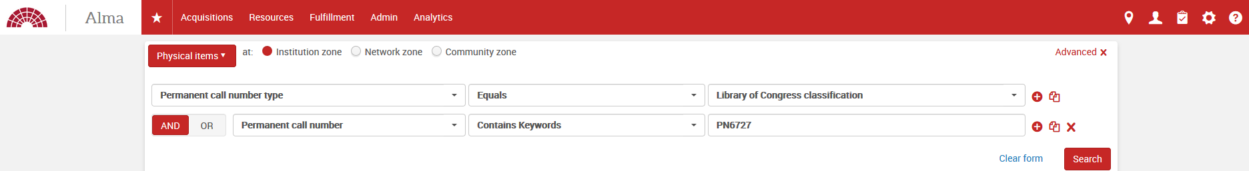

- If your search has produced a lot of results and you want to be able to sort the call numbers in order, click the Export List icon that is in the upper right just below (Save Query) and choose Excel.

- Open the Excel file and under Column U will be a list of call numbers in that range.
- Edit, manipulate, and sort the Excel sheet to your preference.

Advanced methods:

Searching a Specific Range:

If you want to see what we have in a narrow range in the search bar it is best to use the wildcard (*)

- On the right hand side of the search bar, click “Advanced” to bring up an Advanced Search.
- Select “Physical items” on the drop down menu
- Select “Permanent call number type” in the first white drop down menu
- Select “Equals” in the second (middle) box
- Select “Library of Congress Classification” in the third box and hit the “+” symbol next to it to add another search line
- Select “AND” at the start of the second search line
- In the first white drop down menu select “Permanent call number”
- Select “Contains Keywords” in the second (middle) box
- In the first white drop down menu select “Permanent call number” and in the white drop down menu next to it select “Contains Keywords”
- Type in the call number you are looking for and include a wildcard at the end, for example: PN6728.P4 Y* to search for all Peanuts books where the cutter starts with a Y.

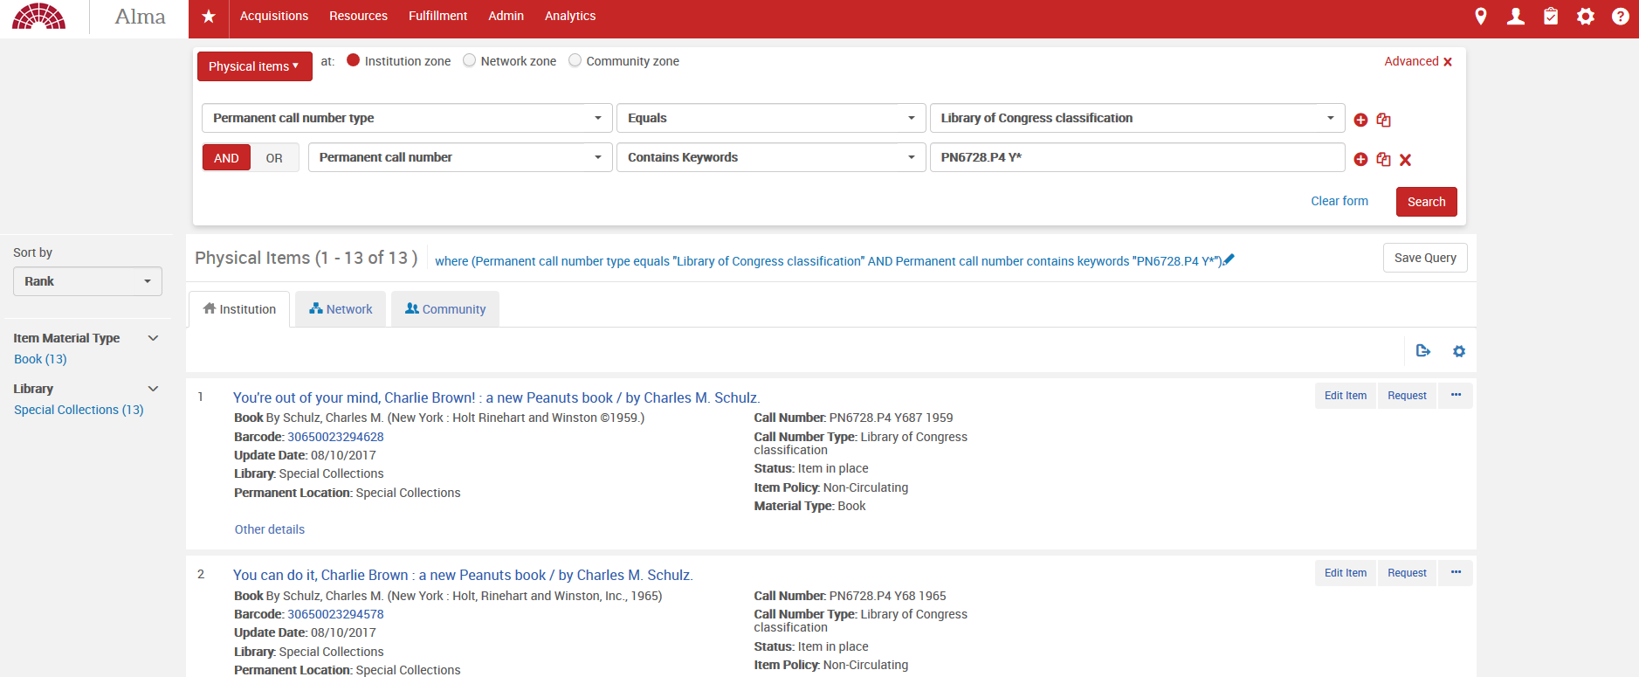

Another example, below, shows all the DVDs that start with DVD-92* . Note that you need to change call number type to “Shelving control number”

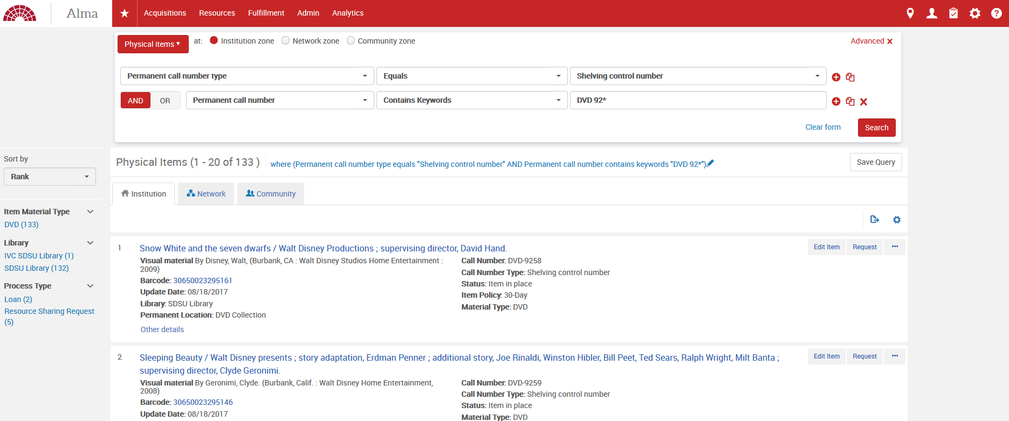

Searching A Narrow Range:

If you have a short range of call numbers you want to search through, you will need to search using “Permanent call number type”. It is found in the “Holdings” drop down.

- Click the plus sign and add in additional fields and include the permanent call number type. You must also decide if it is best to use the AND or OR buttons.
- Click the plus sign again, to add another call number. The example below shows a range of call numbers greater than pn6728 but less than pn6740.
